DBT Assignment 11 – 14
Assignment 11 – Subqueries

- Write a query that uses a subquery to obtain all orders for the customer named Cisneros. Assume you do not know his customer number (cnum).
select * from orders
-> where cnum = ( select cnum from customers
-> where cname = 'Cisneros');

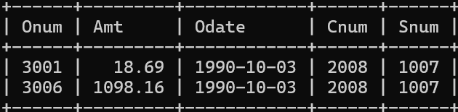

- Write a query that produces the names and ratings of all customers who have above-average orders.
select cname , rating from customers
-> where cnum in ( select cnum from orders
-> where amt > (select avg(amt) from orders)
-> );

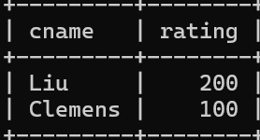

- Write a query that selects the total amount in orders for each salesperson for whom this total is greater than the amount of the largest order in the table.
select snum , sum(amt) from orders
-> group by snum
-> having sum(amt) > ( select max(amt) from orders);
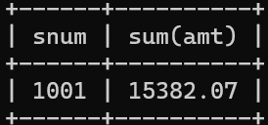

Assignment 12 - Using the operators IN, ANY, and ALL
- Write a query that selects all customers whose ratings are equal to or greater than ANY of Serres’.
select cname , rating from customers
-> where rating >= ANY (
-> select rating from customers
-> where snum = (select snum from salespeople
-> where sname = 'Serres')
-> );
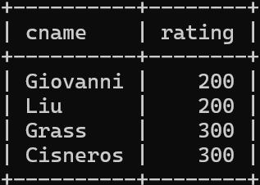

- Write a query using ANY or ALL that will find all salespeople who have no customers located in their city.
select city , sname from salespeople
-> where city != ANY (
-> select city from customers
-> where customers.city <> salespeople.city);
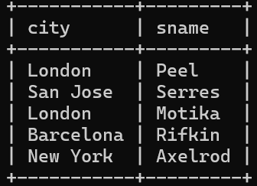

- Write a query that selects all orders for amounts greater than any for the customers in London.
- mysql> select * from orders
-> where amt > ANY( select amt from orders
-> where cnum IN (select cnum from customers
-> where city = 'London'
-> )
-> );
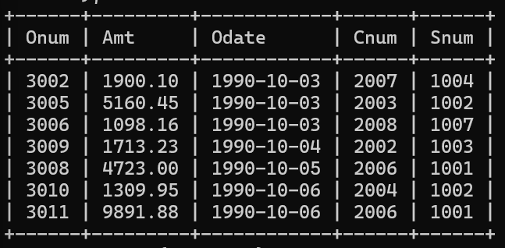
- Write the above query using MIN or MAX.
- select * from orders
-> where amt > (select MIN(amt) from orders
-> where cnum IN (select cnum from customers
-> where city = 'London')
-> );
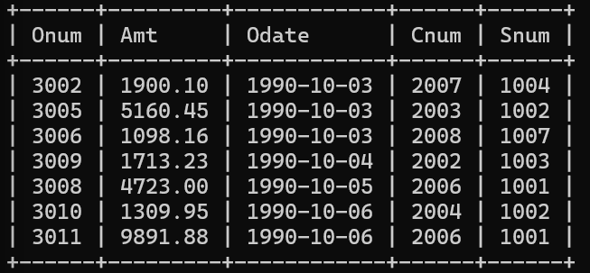

Assignment 13 - Using the UNION clause
- Create a union of two queries that shows the names, cities, and ratings of all customers. Those with rating of 200 or greater will also have the words “High Rating”, while the others will have the words “Low Rating”.
- select cname , city , rating , 'High Rating' as rating_status from customers
-> where rating >= 200
-> union
-> select cname , city , rating , 'Low Rating' as rating_status from customers
-> where rating < 200;
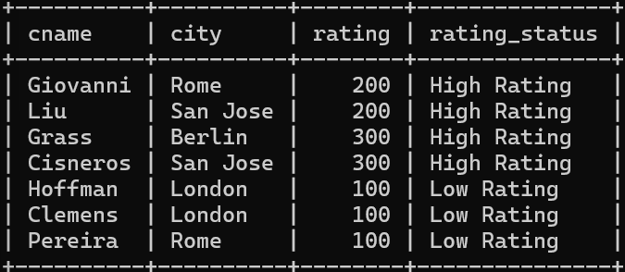
- Write a command that produces the name and number of each salesperson and each customer with more than one current order. Put the results in alphabetical order.
- select s.sname, s.snum, c.cname, c.cnum
-> from salespeople s, customers c
-> where s.snum = c.snum
-> AND c.cnum IN(
-> select cnum
-> from orders
-> group by cnum
-> having count(*) > 1
-> )
-> union
-> select s.sname, s.snum, c.cname, c.cnum
-> from salespeople s, customers c
-> where s.snum = c.snum
-> AND c.cnum IN(
-> select cnum
-> from orders
-> group by cnum
-> having count(*) > 1
-> )
-> order by cname;
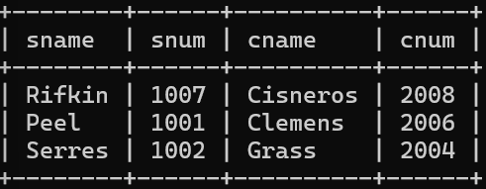
- Form a union of three queries. Have the first select the snums of all salespeople in San Jose; the second, the cnums of all customers in San Jose; and the third the onums of all orders on October 3. Retain duplicates between the last two queries but eliminate any redundancies between either of them and the first. (Note: in the sample tables as given, there would be no such redundancy. This is besides the point.)

SELECT snum FROM salespeople
WHERE city = 'San Jose'

UNION

SELECT cnum FROM customers
WHERE city = 'San Jose'

UNION ALL

SELECT onum FROM orders
WHERE odate = '1990-10-03';



Assignment 14 - Entering, Deleting, and Changing Field Values

- Write a command that puts the following values, in their given order, into the salespeople table: city – San Jose, name – Blanco, comm – NULL, cnum – 1100.
- insert into salespeople(city,sname,comm,snum)
-> values('San Jose','Blanco',NULL,1100);
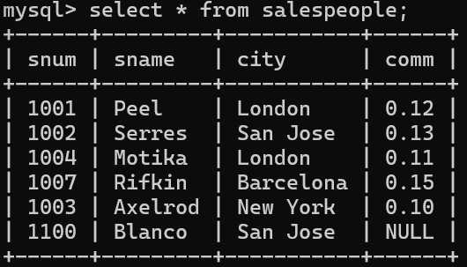

- Write a command that removes all orders from customer Clemens from the Orders table.
- delete from orders
-> where cnum = (select cnum from customers
-> where cname = 'Clemens');
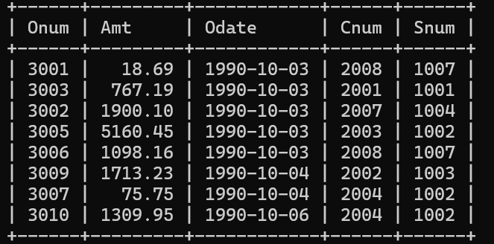

- Write a command that increases the rating of all customers in Rome by 100.
- update customers
-> set rating = rating + 100
-> where city = 'Rome';
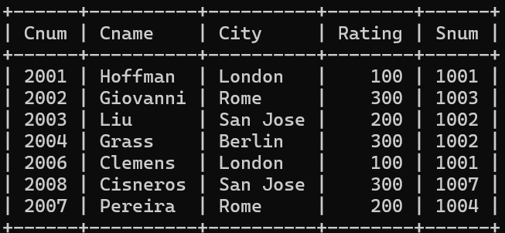

- Salesperson Serres has left the company. Assign her customers to Motika.
- update salespeople
-> set sname = 'Motika'
-> where sname = 'Serres';
